Meet Melanie Heuiser Hill!
She will be visiting our school on Friday, October 19th. Ms. Hill is a graduate of Hamline University’s MFA program in writing for children and young adults. She lives in the Twin Cities with her husband and children. Giant Pumpkin Suite is her debut novel. You can learn more about the author and her book at www.melanieheuiserhill.com. If you would like a signed copy, please return this form with payment to the library by Wednesday, October 17th!

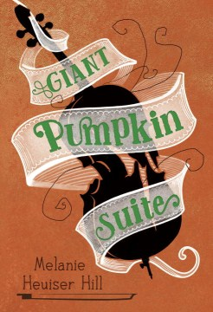  “There's abundant warmth, humor, and heart in this charmer, and readers will root for both characters and pumpkin. A winning debut." --Kirkus Reviews | Giant Pumpkin Suite  Who are you, if you can’t be what you always expected? A moving coming-of-age tale of prodigy and community, unlikely friendship and growing things.  Twelve-year-old Rose Brutigan has grown seven inches in the last eight months. She’s always been different from her twin brother, Thomas, but now she towers over him in too many ways. The gap in their interests continues to widen as well. Rose is focused on winning the upcoming Bach Cello Suites Competition, while happy-go-lucky Thomas has taken up the challenge of growing a giant pumpkin in the yard of their elderly neighbor, Mr. Pickering. But when a serious accident changes the course of the summer, Rose is forced to grow and change in ways she never could have imagined. Along the way there’s tap dancing and classic musicals, mail-order worms and neighborhood-sourced compost, fresh-squeezed lemonade, the Minnesota State Fair — and an eclectic cast of local characters for readers to love. | Hardcover book  $16.70  Cash or  Check  (payable to “The Book Stall ”) enclosed | Personalized to:
Thank You! | ORDERS DUE in the Library by Wednesday, October 17th. | Price reflects a 10% discount  off the cover price. | Total:

Student’s Name: _______________________________________________

Teacher’s Name: _______________________________________________

